Library Management System

1.a) Creating the tables.

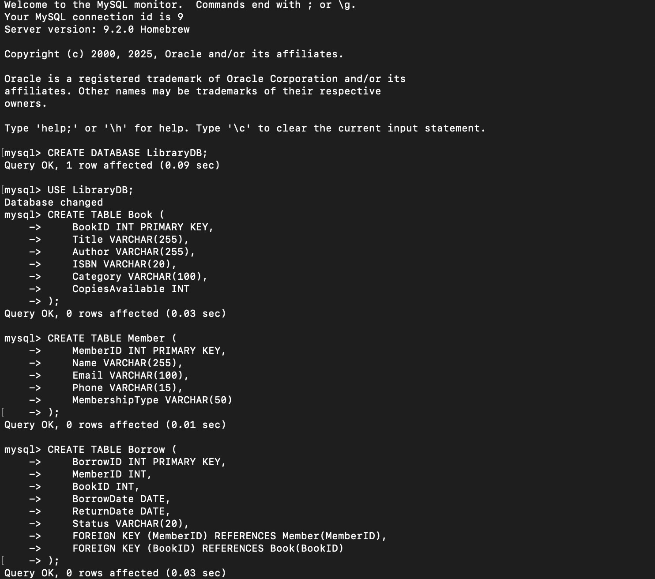

1. Inserting sample data.

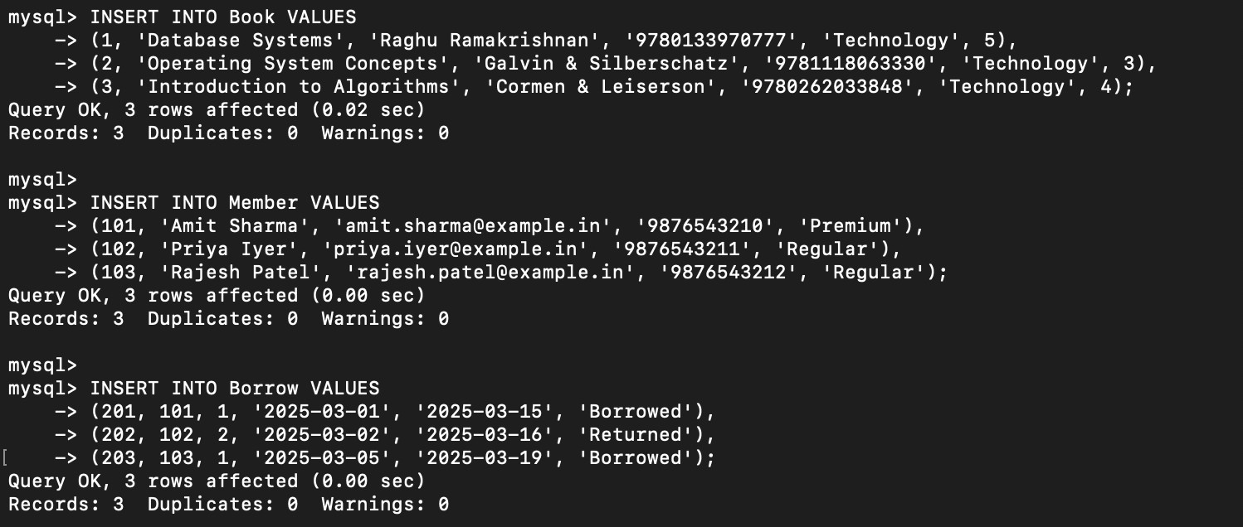

1. Retrieve members who have borrowed “Database Systems” books.

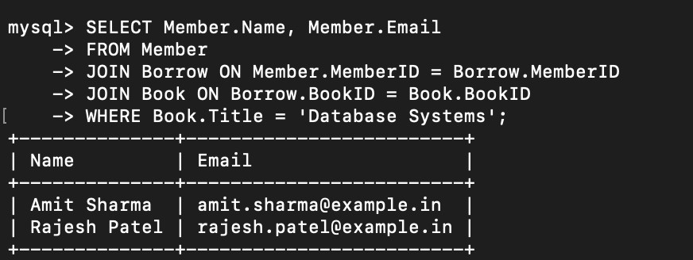

1. Find the number of books borrowed by each member.

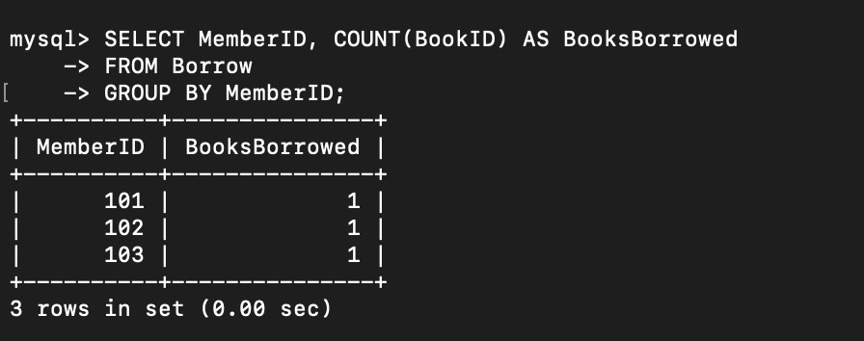

1. Display books that are currently not borrowed.

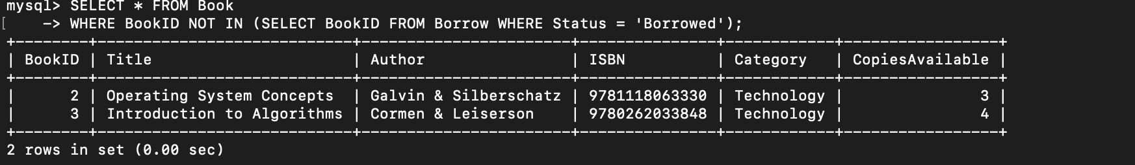

1. Retrieve members who have borrowed the most books.

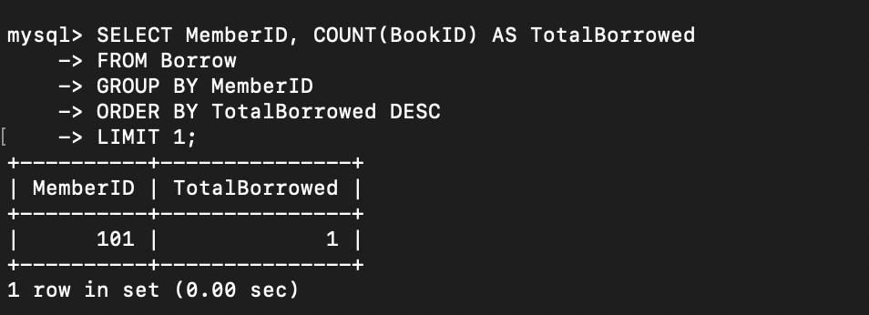

1. List all books with available copies.

